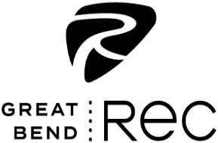 Name The Mascot Contest

Proposed Name of Mascot:
Why is This the Best Choice (Backstory):
Contact Information:
Name: Age:
Parent/Guardian Name if under 16:
Phone Number: ( ) - Email:

Contest is open to all ages and a prize will be awarded to the person who submits the winning name of the Great Bend Rec’s new mascot.
If any proposed names have duplicate entries, then the winner will be selected by the contestant who wrote the best backstory for their name choice.
All entries must be submitted by June 13th and turned in at either the downtown Recreation Center located at 1214 Stone Street, or the Activity Center located at 2715 18th Street.
The winning name will be voted on by the public.

